Particular | Details
Department | Department of Computer Science and Engineering
Programme | B.Tech – Computer Science and Engineering
Course Code & Course Name | CSA0902 – Programming in Java
Academic Year / Batch | 2023–2027
Faculty Name | Dr. V. Sarala
Assignment Title | A Java-based Campus Lost-and-Found Application Using Java Swing and JDBC
Date of Issue | 02-09-2026
Date of Submission | 02-09-2026
Maximum Marks | 100
Course Outcome(s) – CO | CO4: Design GUI-based user interfaces using AWT, Swing, Applets, event handling, layout managers, controls, and menus. CO5: Construct database-driven applications using JDBC to perform SQL operations such as INSERT, UPDATE, DELETE, and retrieval.
Bloom's Taxonomy Level | L3 – Apply; L4 – Analyse
SDG Mapping (SDG 1–17) | SDG 11 – Sustainable Cities and Communities; SDG 12 – Responsible Consumption and Production
Industry / Societal Relevance | The Campus Lost-and-Found Management System provides a practical digital solution for managing lost and found items in educational institutions. It demonstrates industry-relevant skills such as GUI development, event-driven programming, database connectivity, CRUD operations, data validation, and exception handling. Socially, it helps students and staff recover lost belongings efficiently, reduces unnecessary replacement purchases, and promotes responsible resource utilization.

CSA0902 – PROGRAMMING IN JAVA

Assignment Information

1. Problem Statement
Managing lost and found items in a college campus through manual registers, notice boards, or informal communication can be inefficient and time-consuming. Students and staff may find it difficult to report lost belongings, search for found items, update information, or identify whether an item has been returned.
To overcome these limitations, a Campus Lost-and-Found Management System is proposed using Java Swing and JDBC. The application provides a graphical interface through which users can report lost or found items, view existing records, search for items, update information, delete records, and maintain the status of recovered items. The information is stored securely in a MySQL database using JDBC connectivity.

2. Objective
The main objectives of the project are:
- To develop a user-friendly desktop application for managing campus lost and found items.
- To implement a graphical user interface using Java Swing.
- To connect the Java application with a MySQL database using JDBC.
- To implement Create, Read, Update, and Delete (CRUD) operations.
- To provide search functionality for quickly locating item records.
- To validate user input before storing information in the database.
- To implement exception handling for reliable application operation.
- To maintain accurate and synchronized lost-and-found records.
- To demonstrate practical application of Java programming and database concepts.
- To encourage recovery and reuse of lost belongings.

3. Requirements and Environment Used

Hardware Requirements
Requirement | Specification
Processor | Intel Core i3 or above
RAM | 4 GB or above
Storage | Minimum 10 GB free space
Display | Standard monitor
Keyboard/Mouse | Required

Software Requirements
Software | Purpose
Java JDK | Java program development and execution
Java Swing | GUI development
JDBC | Database connectivity
MySQL | Database management
MySQL Connector/J | JDBC driver
IntelliJ IDEA / Eclipse / NetBeans | Development environment
Windows/Linux | Operating system
GitHub | Source-code repository

Technologies Used
- Programming Language: Java
- GUI: Java Swing
- Database: MySQL
- Database Connectivity: JDBC
- Version Control: Git/GitHub

4. Design / Proposed Solution
The proposed system consists of a Java Swing front-end and a MySQL database back-end.

System Architecture
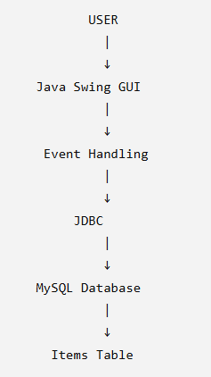

Main Modules

1. Add Item Module
Allows the user to enter details of a lost or found item and save the record.

2. View Module
Displays all item records using a JTable.

3. Search Module
Allows users to search records based on item name, type, location, or status.

4. Update Module
Allows modification of an existing item record.

5. Delete Module
Allows removal of an unwanted or incorrect record.

6. Status Management
The status of an item can be maintained as:
- Active
- Returned

GUI Components
Swing Component | Application
JFrame | Main application window
JPanel | Organizing interface
JLabel | Field names
JTextField | Item name, location, contact, date
JTextArea | Item description
JComboBox | Lost/Found and status
JButton | Add, Update, Delete, Search, Clear
JTable | Display records
JScrollPane | Scroll table
JOptionPane | Messages and confirmations

5. Algorithm / Pseudocode / Flowchart

Algorithm

Step 1
Start the application.

Step 2
Establish a connection between Java and MySQL using JDBC.

Step 3
Display the Campus Lost-and-Found GUI.

Step 4
Load existing records from the database into the JTable.

Step 5
Accept item details from the user.

Step 6
Validate the entered information.

Step 7
Perform the selected operation:
- Add
- Search
- Update
- Delete
- Clear

Step 8
Execute the appropriate SQL query.

Step 9
Display a success or error message.

Step 10
Refresh the JTable.

Step 11
Continue until the user closes the application.

Step 12
End.

Pseudocode
BEGIN

Connect to MySQL database

Display Campus Lost-and-Found GUI

Load all records from database

Display records in JTable

IF Add button is clicked THEN
Read item details
Validate input

IF input is valid THEN
Execute INSERT query
Display success message
Refresh JTable
ELSE
Display validation error
END IF
END IF

IF Search button is clicked THEN
Read search value
Execute SELECT query
Display matching records
END IF

IF Update button is clicked THEN
Select item record
Read modified details
Validate input
Execute UPDATE query
Display success message
Refresh JTable
END IF

IF Delete button is clicked THEN
Select item record
Ask for confirmation

IF user confirms THEN
Execute DELETE query
Display success message
Refresh JTable
END IF
END IF

IF Clear button is clicked THEN
Clear all input fields
END IF

END

Flowchart
START
|
↓
Connect to MySQL
|
↓
Display GUI
|
↓
Load Database Records
|
↓
Display JTable
|
↓
User Action
|
┌────────────┼─────────────┐
↓ ↓ ↓
ADD SEARCH UPDATE
| | |
↓ ↓ ↓
Validate Search DB Validate
| | |
↓ ↓ ↓
INSERT Display UPDATE
| Result |
└────────────┼─────────────┘
|
↓
DELETE
|
↓
Confirm Delete
|
↓
DELETE
|
↓
Refresh JTable
|
↓
END

6. Implementation / Source Code

Database Creation
CREATE DATABASE campus_lost_found;

USE campus_lost_found;

CREATE TABLE items (
item_id INT PRIMARY KEY AUTO_INCREMENT,
item_name VARCHAR(100) NOT NULL,
item_type VARCHAR(20) NOT NULL,
description VARCHAR(500),
location VARCHAR(150) NOT NULL,
item_date DATE NOT NULL,
contact VARCHAR(100) NOT NULL,
status VARCHAR(30) DEFAULT 'Active'
);

Sample Records
INSERT INTO items
(item_name, item_type, description, location,
item_date, contact, status)
VALUES
('Black Wallet', 'Lost', 'Black leather wallet',
'CSE Block', '2026-09-02', '9876543210', 'Active'),

('Wrist Watch', 'Found', 'Titan wrist watch',
'Library', '2026-09-01', '9123456780', 'Active'),

('ID Card', 'Lost', 'College ID Card',
'Admin Block', '2026-08-31', '9988776655', 'Returned'),

('Water Bottle', 'Found', 'Blue water bottle',
'Playground', '2026-08-30', '9001122334', 'Active');

JDBC Connection
import java.sql.Connection;
import java.sql.DriverManager;

public class DBConnection {

private static final String URL =
"jdbc:mysql://localhost:3306/campus_lost_found";

private static final String USER = "root";
private static final String PASSWORD = "your_password";

public static Connection getConnection()
throws Exception {

return DriverManager.getConnection(
URL, USER, PASSWORD
);
}
}

INSERT Operation
String sql =
"INSERT INTO items " +
"(item_name, item_type, description, location, " +
"item_date, contact, status) " +
"VALUES (?, ?, ?, ?, ?, ?, ?)";

PreparedStatement ps =
con.prepareStatement(sql);

ps.setString(1, itemName);
ps.setString(2, itemType);
ps.setString(3, description);
ps.setString(4, location);
ps.setString(5, itemDate);
ps.setString(6, contact);
ps.setString(7, status);

ps.executeUpdate();

SELECT Operation
String sql = "SELECT * FROM items";

PreparedStatement ps =
con.prepareStatement(sql);

ResultSet rs = ps.executeQuery();

while (rs.next()) {
int id = rs.getInt("item_id");
String name = rs.getString("item_name");
String type = rs.getString("item_type");
}

UPDATE Operation
String sql =
"UPDATE items SET item_name=?, item_type=?, " +
"description=?, location=?, item_date=?, " +
"contact=?, status=? WHERE item_id=?";

PreparedStatement ps =
con.prepareStatement(sql);

ps.setString(1, itemName);
ps.setString(2, itemType);
ps.setString(3, description);
ps.setString(4, location);
ps.setString(5, itemDate);
ps.setString(6, contact);
ps.setString(7, status);
ps.setInt(8, itemId);

ps.executeUpdate();

DELETE Operation
String sql =
"DELETE FROM items WHERE item_id=?";

PreparedStatement ps =
con.prepareStatement(sql);

ps.setInt(1, itemId);

ps.executeUpdate();

7. Test Cases and Expected/Actual Results
Test Case | Test Input/Action | Expected Result | Actual Result
TC01 | Open application | GUI should open | Passed
TC02 | Add valid item | Item should be inserted | Passed
TC03 | Leave item name empty | Validation message | Passed
TC04 | Search "Wallet" | Wallet records displayed | Passed
TC05 | Update location | Record should update | Passed
TC06 | Delete selected record | Record should be deleted | Passed
TC07 | Click Clear | Fields should become empty | Passed
TC08 | Change status to Returned | Status should update | Passed
TC09 | Invalid contact | Error message displayed | Passed
TC10 | Database unavailable | Exception should be handled | Passed

8. Execution Screenshots / Output
The following screenshots can be included in the report:

Figure 1: Main Application Window
Shows the complete Campus Lost-and-Found GUI with:
- Item fields
- Search section
- Buttons
- JTable
- Existing records
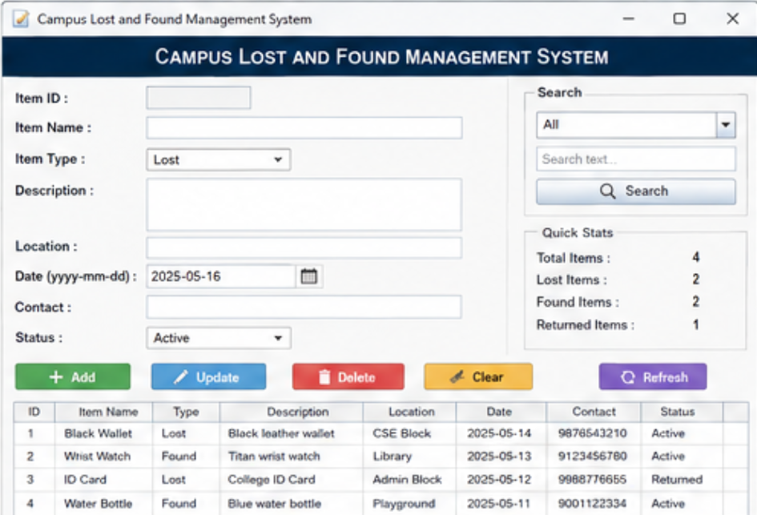

Figure 2: Add Item
Shows a new lost/found item entered into the form.
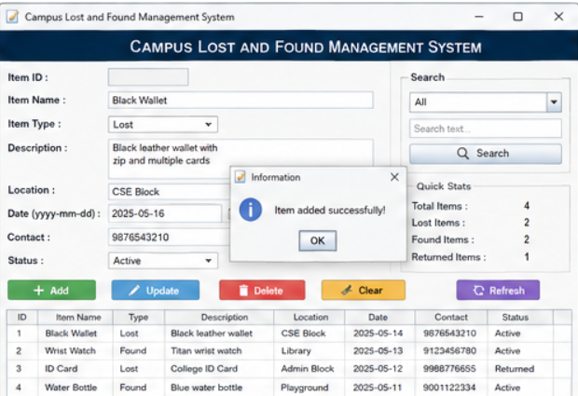

Figure 3: Successful Addition
Shows the message:
Item added successfully.

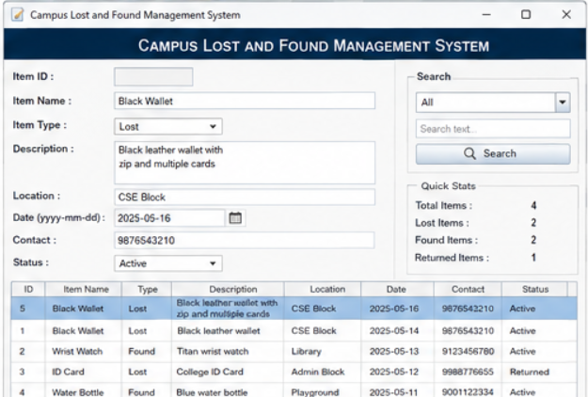

Figure 4: Search Result
Shows search results for an item such as:
Wallet

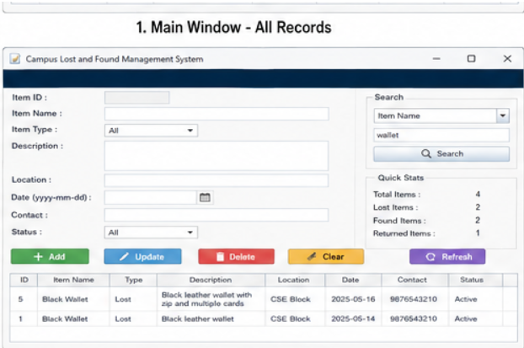

Figure 5: Update Operation
Shows an existing item being modified.
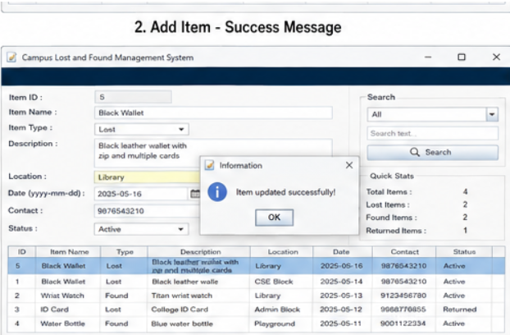

Figure 6: Update Success
Shows:
Item updated successfully.


Figure 7: Delete Confirmation
Shows:
Are you sure you want to delete this item?
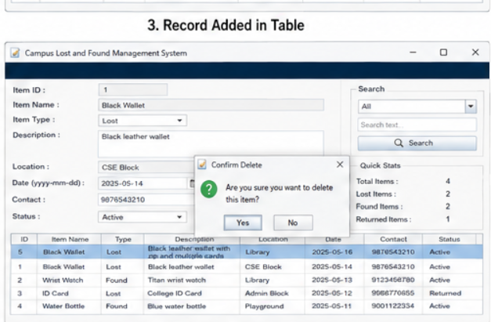

Figure 8: Returned Status
Shows an item's status changed from:
Active → Returned
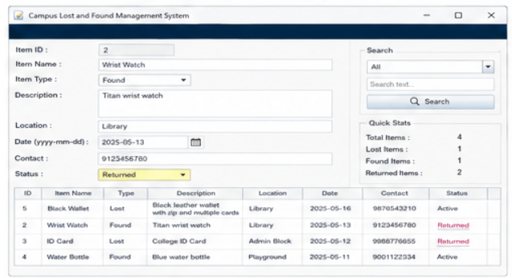

Figure 9: MySQL Database
Shows the items table and stored records.
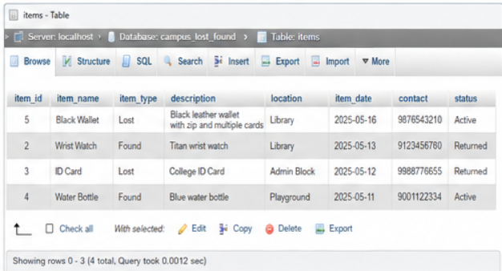

9. Analysis and Discussion
The developed system successfully integrates a Java Swing graphical interface with a MySQL database using JDBC. The application provides an organized way to maintain campus lost-and-found information.
The use of Swing components makes the system interactive and easy to use. JTable provides a convenient way to display multiple records, while JComboBox reduces incorrect input for predefined values such as Lost, Found, Active, and Returned.
JDBC provides communication between the Java application and MySQL. The implementation of CRUD operations ensures that records can be inserted, retrieved, updated, and deleted efficiently. PreparedStatement is used for database operations, making the SQL implementation more structured and safer than constructing queries directly from user input.
Input validation prevents incomplete records from being inserted. Exception handling provides meaningful feedback when errors occur. The system can therefore reduce manual work and improve the accuracy and accessibility of lost-and-found records.
The project also demonstrates the practical application of CO4 and CO5. CO4 is achieved through Swing GUI design and event handling, while CO5 is achieved through JDBC connectivity and SQL-based CRUD operations.

10. Conclusion
The Campus Lost-and-Found Management System was successfully designed and developed using Java Swing, JDBC, and MySQL. The system provides essential features such as adding, viewing, searching, updating, deleting, and managing the status of lost and found items.
The project demonstrates the practical use of Java GUI components, event handling, database connectivity, SQL queries, CRUD operations, validation, and exception handling. It provides a simple and effective solution for maintaining lost-and-found records within a campus.
The system also supports SDG 11 – Sustainable Cities and Communities by contributing to an organized campus environment and SDG 12 – Responsible Consumption and Production by encouraging students to recover and reuse their existing belongings instead of unnecessarily purchasing replacements.

11. Individual Contribution of Group Members
Fill this according to your actual group work.
Group Member | Contribution
Member 1 | Designed the Java Swing GUI and implemented event handling.
Member 2 | Designed the MySQL database and implemented JDBC connectivity.
Member 3 | Implemented CRUD operations and search functionality.
Member 4 | Performed testing, validation, documentation, and GitHub management.
If you have only 3 members, you can use:
Group Member | Contribution
Member 1 | GUI design, Swing components, and event handling
Member 2 | MySQL database, JDBC connectivity, and CRUD operations
Member 3 | Testing, validation, screenshots, documentation, and GitHub upload

12. References
You can include the following references:
- Oracle Java Documentation – Java programming and Swing concepts.
- Oracle JDBC Documentation – JDBC connectivity and database operations.
- MySQL Documentation – Database creation and SQL commands.
- Course notes and laboratory materials for CSA0902 – Programming in Java.
- Java Swing API documentation for GUI components and event handling.

13. GitHub Upload
The completed project should be uploaded to GitHub with a suitable repository name such as:
Campus-Lost-and-Found-Java
Recommended structure:
Campus-Lost-and-Found-Java/
│
├── src/
│ ├── Main.java
│ ├── DBConnection.java
│ ├── Item.java
│ ├── ItemDAO.java
│ └── LostFoundApp.java
│
├── database/
│ └── campus_lost_found.sql
│
├── screenshots/
│ ├── main-window.png
│ ├── add-item.png
│ ├── search-result.png
│ ├── update.png
│ ├── delete.png
│ └── database.png
│
├── README.md
└── .gitignore
The README.md should contain the project description, technologies used, features, database setup, requirements, and instructions for running the application.

ONE-PAGE WRITE-UP
The Campus Lost-and-Found Management System is a Java-based desktop application designed to provide an organized and efficient solution for managing lost and found items within a college campus. The project is developed as part of the CSA0902 – Programming in Java course and focuses on applying Java Swing for graphical user interface development and JDBC for database connectivity. The system aims to replace traditional manual methods of reporting and tracking lost belongings with a centralized digital application.
The application provides a user-friendly graphical interface through Java Swing components such as JFrame, JPanel, JLabel, JTextField, JTextArea, JComboBox, JButton, JTable, JScrollPane, and JOptionPane. Users can enter information about lost or found items, including item name, item type, description, location, date, contact details, and current status. The records are displayed in a table, allowing users to easily view and manage the available information.
The system implements the major CRUD operations—Create, Read, Update, and Delete. Users can report a new lost or found item, retrieve and view existing records, update incorrect or changed information, and delete unnecessary records. A search facility can also be provided to find items based on details such as item name, type, location, or status. Input validation is incorporated to prevent incomplete or invalid information from being stored, while exception handling provides appropriate feedback when application or database errors occur.
For data storage, the application uses MySQL and connects to the database through Java Database Connectivity (JDBC). A structured database table is created with an appropriate primary key and fields for storing item information. PreparedStatement is used for executing SQL operations, providing a reliable approach for interacting with the database. After an operation such as insertion, update, or deletion, the graphical table is refreshed so that the displayed information remains synchronized with the database.
The project demonstrates the CO4 and CO5 course outcomes. CO4 is achieved through the design and implementation of a GUI using Java Swing, along with event handling and user interaction. CO5 is demonstrated through JDBC connectivity and the implementation of SQL-based database operations. The assignment involves L3 – Apply and L4 – Analyse levels of Bloom's Taxonomy because students apply Java programming concepts to develop the application and analyse requirements, database structures, user interactions, and possible errors.
The project also has societal relevance through its connection with SDG 11 – Sustainable Cities and Communities and SDG 12 – Responsible Consumption and Production. By helping students and staff recover lost belongings, the system contributes to a more organized and efficient campus community. Recovering existing items can also reduce unnecessary purchases of replacement products, thereby encouraging responsible consumption and reducing avoidable resource usage.
Overall, this assignment provides practical experience in Java programming, Swing GUI development, event-driven programming, JDBC, MySQL, SQL CRUD operations, validation, exception handling, and database management. It bridges theoretical programming concepts with a real-world campus problem and helps develop skills that are relevant to software development and database-driven application design.

